9.1.1.01 It will not completely recycle through the shorter set- e.g. 1 2 3 4 5 + 1 2 3 will result in 2 4 6 5 7

9.1.2.02

Sequence goes backwards

9.1.3.1

It returns the first third and fifth values in the z array

9.1.3.02

> z[c(2,1,3)]

9.1.3.03

It creates an array of the mininum necessary size, with all the places after the original array and before the new value set to NA

9.1.3.04

> x<-1:10

> y<-(x-1/x+1)

> plot(x,y)

9.1.3.05

This is too large a precision to handle this many decimals, so it is truncated to 2.

9.1.3.06

> g<-.5^(0:10)

> g

[1] 1.0000000000 0.5000000000 0.2500000000

[4] 0.1250000000 0.0625000000 0.0312500000

[7] 0.0156250000 0.0078125000 0.0039062500

[10] 0.0019531250 0.0009765625

> sum(g)

[1] 1.999023

> g<-.5^(0:50)

> sum(g)

[1] 2

9.1.5.1

Because this would change your initial light dataset thus losing some of your data which you don’t necessarily want to get rid of

9.1.5.2

> f<-runif(20)

> h<-f[f<mean(f)]

> h

[1] 0.37048491 0.19485239 0.20102415

[4] 0.01852663 0.35419443 0.42508459

[7] 0.19946969 0.02624909 0.25295591

> f<-runif(20)

> h<-f[f<mean(f)]

> h

[1] 0.37048491 0.19485239 0.20102415

[4] 0.01852663 0.35419443 0.42508459

[7] 0.19946969 0.02624909 0.25295591

> i<-which(f<mean(f))

> i

[1] 1 3 4 7 11 13 17 18 20

9.1.5.04

Method 1: > n<-m[seq(1,length(m),2)]

9.2.1.01

>matrix(1,50,50)

> x<-matrix(c(1,2,1,2,1,2,1,2),2,4)

9.2.1.02

I don’t know how to do this

9.2.2.01, because then you are trying to combine columns of c (which are size 3), with those of d size 2), so basically you end up with entries in c that cannot be combined with anything

9.3.0.01

We fit the data in x into a matrix with those specific dimensions (rows and cols)

9.6.0.01

$ Year : int 1950 1950 1952 1953 1953 1954 1954 1954 1955 1955 ...

$ Name : Factor w/ 83 levels "Able","Agnes",..: 38 77 1 9 47 20 40 60 27 33 ...

$ MasFem : num 6.78 1.39 3.83 9.83 8.33 ...

$ MinPressure_before : int 958 955 985 987 985 960 954 938 962 987 ...

$ Minpressure_Updated.2014: int 960 955 985 987 985 960 954 938 962 987 ...

$ Gender_MF : int 1 0 0 1 1 1 1 1 1 1 ...

$ Category : int 3 3 1 1 1 3 3 4 3 1 ...

$ alldeaths : int 2 4 3 1 0 60 20 20 0 200 ...

$ NDAM : int 1590 5350 150 58 15 19321 3230 24260 2030 14730 ...

$ Elapsed.Yrs : int 63 63 61 60 60 59 59 59 58 58 ...

$ Source : Factor w/ 3 levels "http://www.nhc.noaa.gov/pdf/NWS-TPC-5.pdf",..: 2 2 2 2 2 2 2 2 2 2 ...

$ ZMasFem : num -0.00094 -1.67076 -0.91331 0.94587 0.48108 ...

$ ZMinPressure_A : num -0.356 -0.511 1.038 1.141 1.038 ...

$ ZNDAM : num -0.439 -0.148 -0.55 -0.558 -0.561 …

11.01

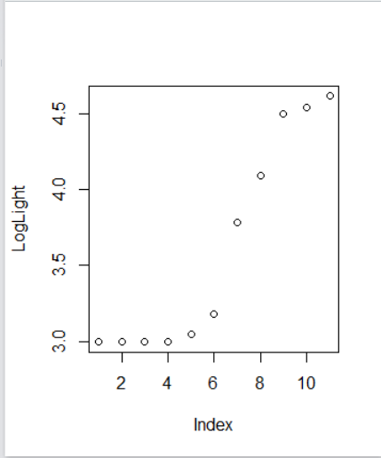

12.1.0.0.2

Iterates twice, because 0 is less than 1, so it goes along the list backwards

12.2

40 iterations required (obtained using counter)